Data Validation Checklist for E-Commerce System
Leena Alomar

System Overview:
This checklist is based on a scenario of an e-commerce platform similar to Amazon, Noon, or other online stores.
The platform connects customers, employees, and suppliers/companies, allowing customers to place orders online while employees manage orders and suppliers provide products.
Validating data ensures that customer details, employee information, and product or supplier records are accurate and consistent, helping prevent errors in orders, payments, and deliveries

Customer Model:

Represents a customer using the e-commerce platform. It includes personal information such as ID, first name, last name, email, phone number, address, country, age, gender, and payment method. Validation ensures that all fields are complete, correctly formatted, and meet minimum requirements, helping prevent errors in order processing and payments.
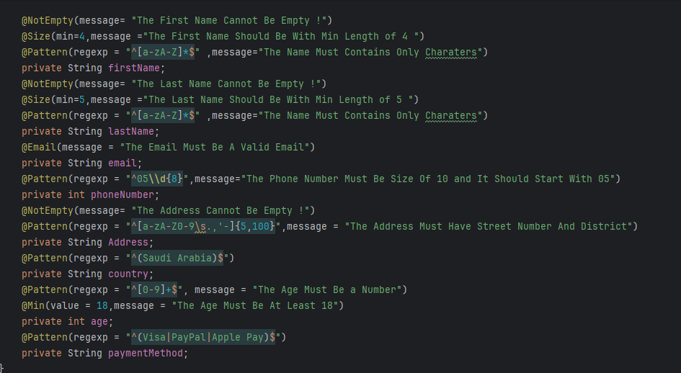

Employee Model:

Represents an employee managing orders or other operations on the platform. It includes first name, last name, department, email, phone number, employment type, and gender. Validations ensure proper formatting, completeness, and authorized roles to maintain system integrity and prevent operational errors.

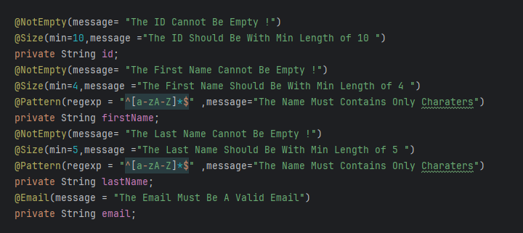
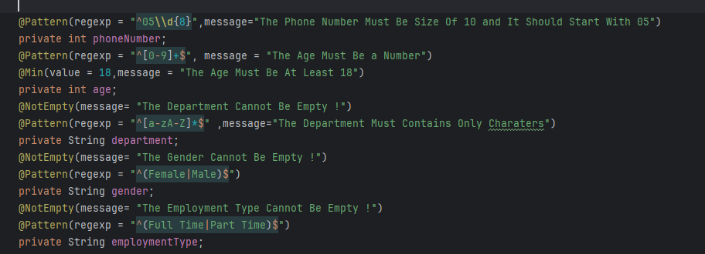

Product Model:

Represents a product available on the platform. It includes product ID, product name, price, quantity, category, and supplier name. Validation rules enforce completeness, correct formats, positive values for price and quantity, and correct categorization, ensuring accurate listings and reliable transactions.

